CS3570 Introduction to Multimedia

Homework #3

Due: 11:59pm, 2018/5/2

Write a program for motion estimation (ME) using the block matching methods on the given video sequence. You have to implement two search algorithms to find motion vectors, the **Full Search** and the **3-Step Search** method. The search range is ±𝒑 pixels along horizontal and vertical directions. In this implementation, you should apply the ME to evaluate the motion vectors, and the block matching measure is defined as Sum of Absolute Differences (**SAD**).

1. **(70%)** Try the two search ranges (**p=8 and p=16**) and two macroblock sizes (**8x8 and 16x16**) by using the **two search methods**. The reference image is **frame437.jpg**, and the target image is **frame439.jpg**.

1. a. Show the predicted images by using the block matching with all the above combinations**. (8 images)**
2. b. Show the motion vectors images for all the above combinations**. (8 images)**
3. c. Show the residual images for all the above combinations**. (8 images)**
4. d. Plot the total SAD values and PSNR for all the results. Discuss the relation between SAD and PSNR.

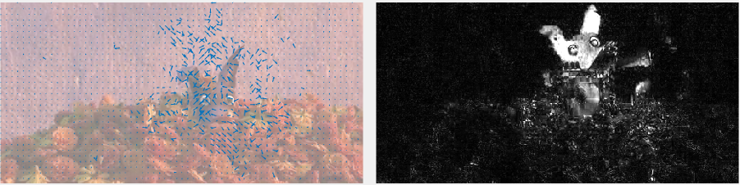

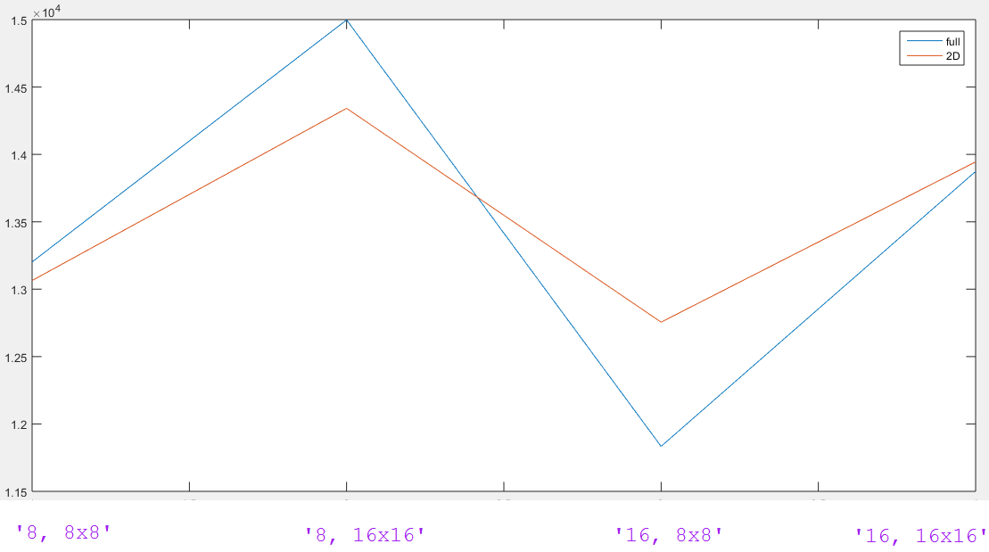

2. **(10%)** Try the full search method with search range **p=8** and macroblock sizes = **8x8**. The reference image is **frame432.jpg**, and the target image is **frame439.jpg**. Show the PSNR of the result. Compare and discuss the PSNR with the result of same search range and macroblock in question 1.

3. **(20%)** Analyze the time complexity

1. a. Measure the execution time required for the two search algorithms with the two different search range sizes **(p=8 and p=16)**.
2. b. Compare and discuss the execution time with the theoretical time complexity.

**Reminder**

* Motion Vector can be represented by (*x*ref – *x*target, *y*ref – *y*target).
* If the position is outside the search range, you can just skip it.
* For RGB image, SAD is obtained by the total difference of three channels.
* PSNR is calculated between target image and the predicted (reconstructed) image.
* PSNR should be conducted by the unit8 images.
* You cannot use Matlab build-in function “imabsdiff”, “psnr”, ‘quiver’.
* Your code should work correctly and generated results (display or output files). It must be consistent to your results in report.
* In report, it should contain all the results **(predicted images, motion vectors images, residual images, total SAD, PSNR)** mentioned in the problem, and how you implement the methods, the **discussion** about the output results, and reference.
* [-5%] Save the report as **“[YourID]_report.pdf”**.
* [-5%] Please compress all your codes, output images and report into .zip and name it **“HW3_[YourID].zip”**.
* [-5%] Your package should also contain a **README file** about how to execute your program.